OPEN CALL – The Žižkov Dovecote
On May 3, 2021, for artists, architects, designers, and art or combined groups

The Prague City Gallery hereby makes the first open call for projects and artistic realization of the first city dovecote in the Vítkov Park.

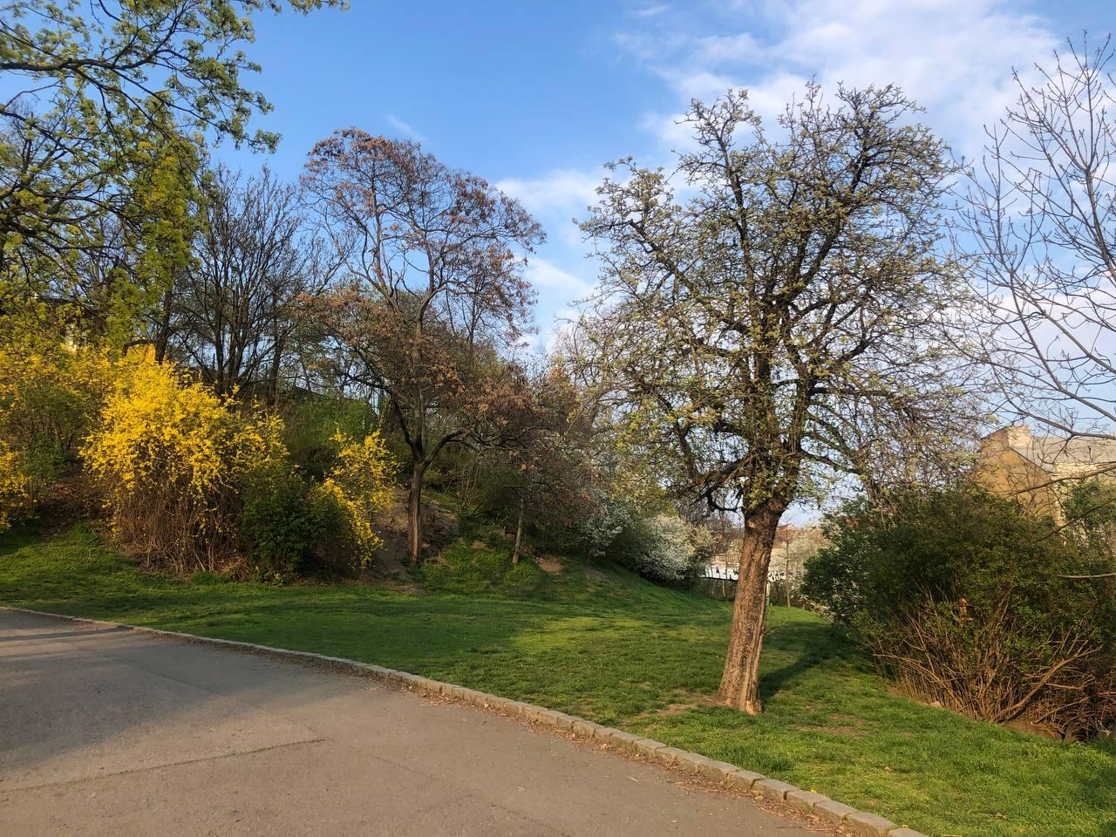

The City of Prague launched the program “Art for the City” in 2018, in order to support contemporary art in the public space. This year, the program was extended with temporary installations and short-term art interventions. Temporary installations in the Prague public space now include the project of the artistic realization of the city dovecote in the Vítkov Park. The regulation of the pigeon population in the city is a problem faced by all city districts. Pigeons are often caught and then gassed unethically. The town hall of City District Prague 3 abandoned this procedure but the issue of the overpopulation of pigeons remains. The best alternative of the usual regulation ways is probably the establishment of city dovecotes, as seen in cities around the world, for example in Germany. Sometimes, a dovecote isn’t merely a wooden structure but a sophisticated works of art and architecture. The Prague City Gallery decided, in cooperation with the City District Prague 3, for an open call for the artistic realization of the city dovecote in the Vítkov Park.

- TARGET AUDIENCE OF THE CALL:

- Artists, architects, designers, and art groups.
- The call is non-anonymous, open to everyone.

- ESTIMATED DATE OF REALIZATION: Autumn 2021 (the best option is October 4, the World Animal Day)

- PROJECT THEME
- The project should work in the urban area and city park context, and sensibly respond to the local functions and social/historic relations.
- Also the functionality of the dovecote is important.
- An obvious option is to connect functional art with the educational and philosophical aspects of the relations between humans and nature, the ways humans treat animals etc.
- LOCATION / AREA: 50.088150, 14.454775
The flat area in the bend of the path on the southern slope of the Vítkov hill, above the Tachovské Square. The size of the area is about 200 m². There is no water or power supply in the area.

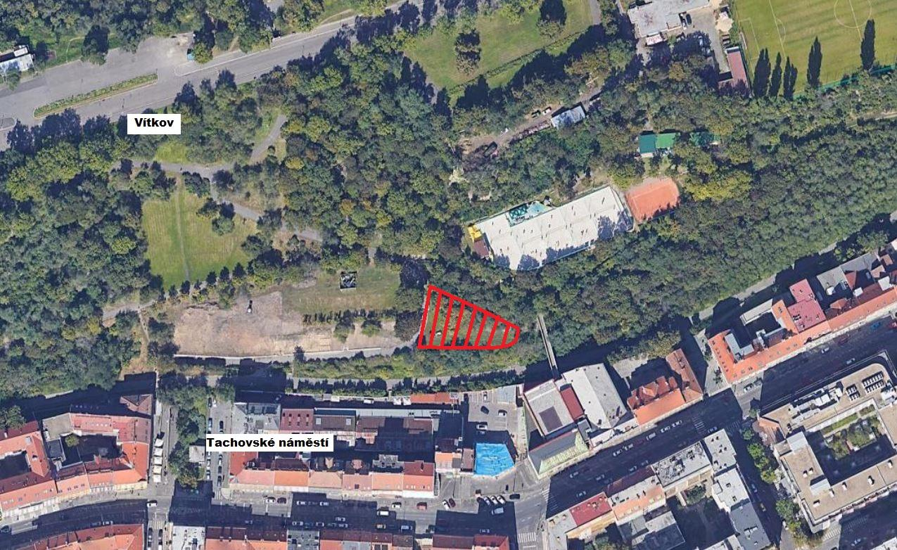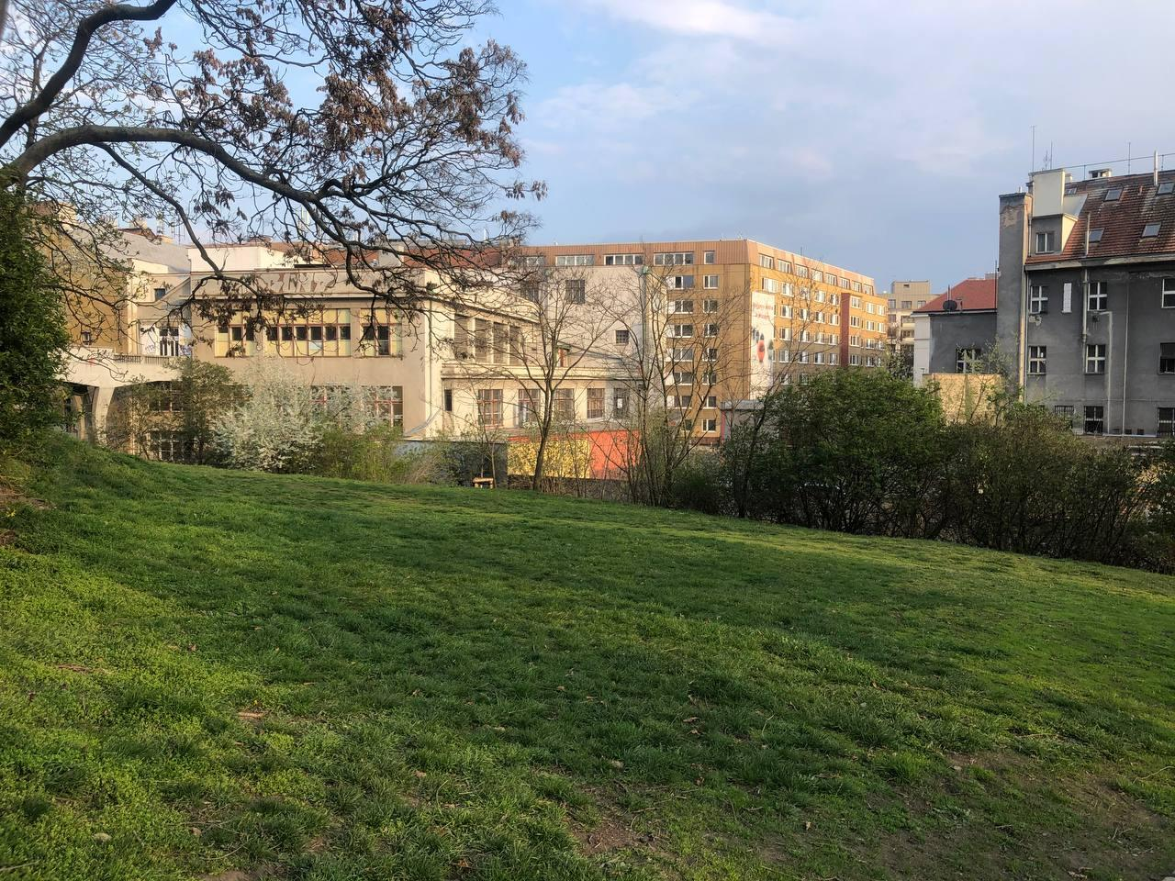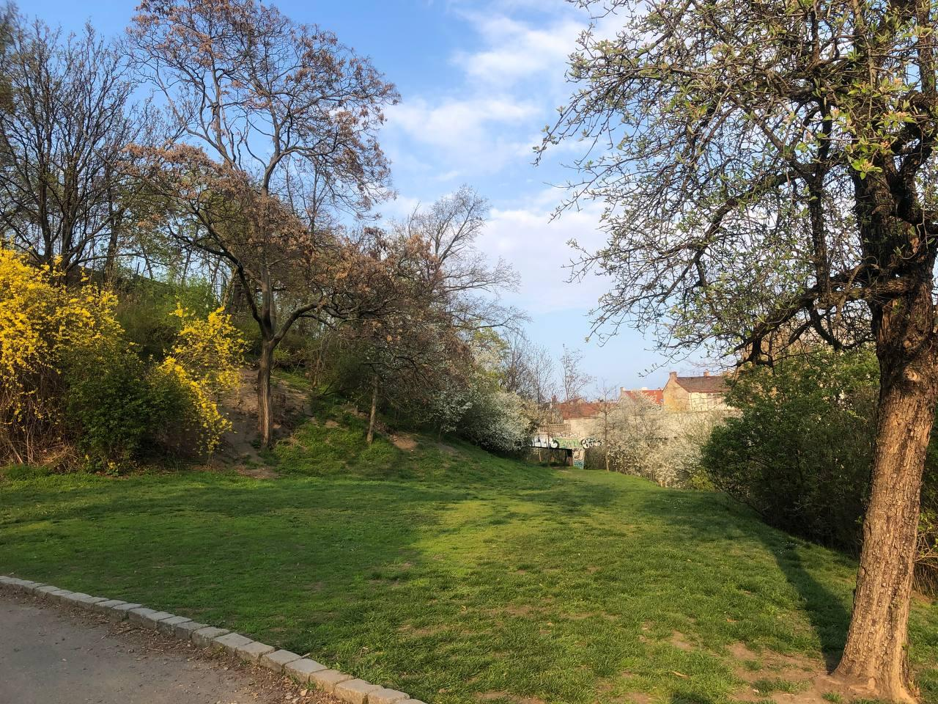
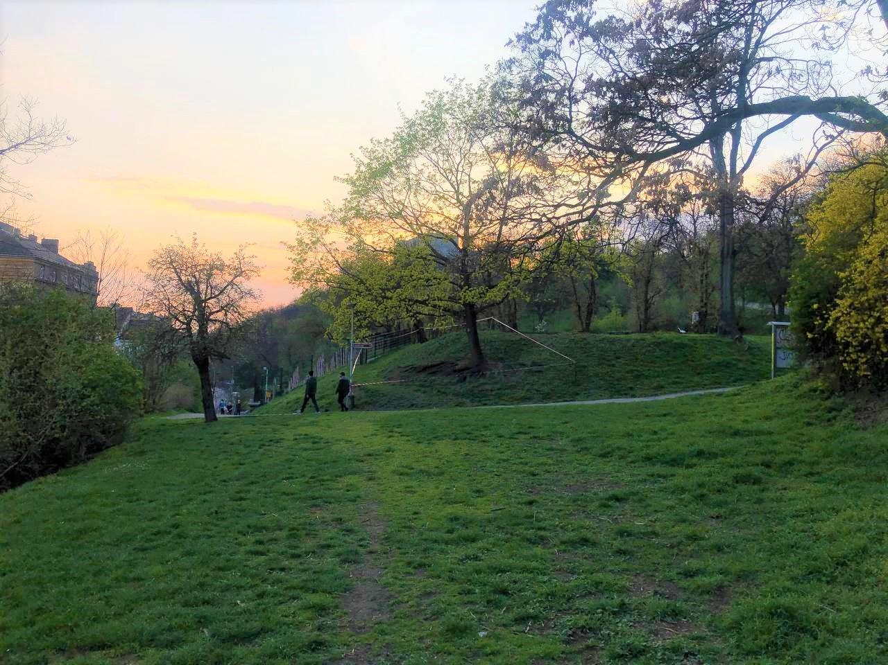

- TECHNICAL REQUIREMENTS FOR THE INSTALLATION
Structure
- Solid or mobile foundations (the latter option is preferred but not obligatory).
- At least one window, possibly on the southern side, and one entrance for humans. No hole from the north.
- Entrance holes for birds should be located on the east or south, at least 10 holes; the maximum number isn’t limited. All holes must be fitted with landing shelves and protruding boards (at least 10 cm). It should be possible to close the holes, preferably all at once. See pictures below for the examples of the holes.
- The bird holes should be located in the way that enables the maximum use of the inner walls, e.g. in the upper part of the dovecote.
- The minimum size of the bird holes is 10x15 Carolinum (width/height).
- The daylight should enter the dovecote, possibly from the south or from the east.
Material
The most frequently used outer materials are wood (not plywood), metal, or concrete. In all cases, except wood, the walls must be thermally insulated so the dovecote doesn’t overheat in summer. In the insulation layer, any material that attracts mites should be avoided. Possible materials include cement-bonded boards, plastics or plasterboards. The inner walls of the dovecote should be smooth and easy to wash.
The dovecote must be easy to ventilate.
Inner equipment of the dovecote
- Separate chamber about 2 m² large, to store materials and bird food.
- Nesting boxes for about 50 pigeons and seating for about 150 ones; the overall capacity is 150 – 200 pigeons. The examples of nesting boxes and seats are shown below.
- Boxes and seating perches must be fitted on the walls, so their location should be already considered when designing the bird holes.
All parts of the dovecote must be accessible for cleaning.

Example of bird holes
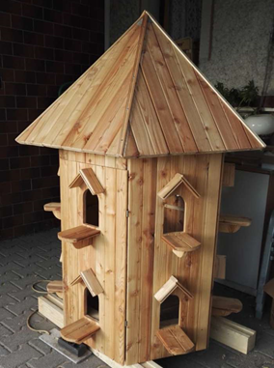

Example of nesting boxes and seating perches
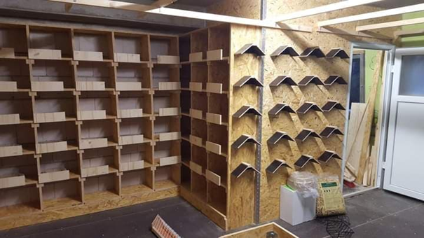

- MAXIMUM PROJECT BUDGET

Czk 500,000 (VAT included)

- This budget must include all project costs, including the costs for the necessary production team (fees included), all material needed for the realization, additional staff and services, or subcontractor fees for various supplies, loans of technology, transport costs etc.
- The project and its budget must also include the graphic design of the exhibition (the visual presentation, captions, outdoor credit panel etc.).
- Any required repairs or adjustments of the surrounding areas must also be included in the budget.
- The budget must also include the costs for the detailed technical documentation.

- STRUCTURE OF THE PROPOSAL:

- Proposal description and possibly its theme (text). Vision of the impact on viewers and relations with the surrounding areas.
- Proposal of the technological solution – description.
- Brief profiles of authors, and/or the portfolio of the curator/artist.
- Estimated budget for the realization (including all fees for curators and artists, and costs for materials and the realization, including required services).

REQUIRED ATTACHMENTS TO THE PROPOSAL:
- Application form
- Detailed budget
- Technical sketch (to be converted into full documentation in case of realization)
- The artist’s portfolio
- Visualization of the project in print quality for at least A3 size (technical sketch, illustration, study, project documentation or computer-based visualization).

The proposal should give the Committee a sufficient idea of the result and project feasibility.

- AWARDS
1st place – Czk 30,000
2nd place – Czk 20,000
3rd place – Czk 10,000

- assessment CRITERIA:

- Project originality, artistic value and quality of the proposal
- Local context – the specific nature of the surroundings, including historic, cultural and social relations
- Feasibility – functionality for pigeons, respect to the local limits, rules and safety standards, and the presence of people in the public space

- MORE INFORMATION ON THE PROJECT:

- The Dovecote project is part of the program “Art for the City”. The Prague City Gallery is the guarantor of the program and also the curator of the UM 2021 project for temporary interventions of contemporary art in the public space. The funding of the call and realizations of the projects in the program “Art for the City” is provided by the Prague City Gallery.
- The appropriation of the area (if necessary) for the time of the installation and dismounting of the project is organized by the Prague City Gallery; it’s not a part of the budget.
- The budget will be considered binding. The winning project must be realized under the terms of the budget.
- The proposals will not be evaluated based on their economic features.
- The proposals must respect the principles of the open and democratic society.
- The sensitive integration into the surroundings is expected. No part of the project can cause any hazard to the public or transport.
- The financial reward will be provided for three of the best proposals, based on the Committee verdict. In case the Committee doesn’t announce the winner, there will be no realization and the organizer will make another call.
- Neither the Prague City Gallery nor the City District Prague 3 provide constant security supervision of the dovecote. In case of a substantial damage, terms of repairs will be negotiated with the authors.
- After the realization, the City District Prague 3 will fund the operations of the dovecote using their own funds.

- TERMS AND DEADLINES FOR APPLICATION FORMS:

- Please send your completed application forms, with required attachments, until the midnight of July 8, 2021 to the following e-mail addresses: umenipromesto@ghmp.cz, anna.gumplova@ghmp.cz
- PDF or JPG files are preferred. Please keep the size of the attachments below 10 MB.

- ANNOUNCEMENT OF THE RESULTS:
The winning and awarded proposals will be announced on July 21, 2021, on the website https://umenipromesto.eu.
The Prague City Gallery considers the submitted projects binding; a contract for work will be signed with the winner. The Prague City Gallery also reserves the right to withdraw from the competition in case of insufficient number of applicants. In case of poor quality of the proposals, the Prague City Gallery reserves the right to refuse the realization. The proposals submitted within the deadline, including the required attachments, will be assessed by the Committee consisting of art theoreticians, curators, architects and representatives of the Prague City Hall, city district and location owner. There is no appeal possible against the decision of the Committee.
The lineup of the Committee will be published on the website of the project “Art for the City”: https://umenipromesto.eu before May 30, 2021.
A written record will be made the meeting of the Committee, including the list of all evaluated artworks and the verdicts. The record will include the list of all attending Committee members, with their signatures. The meeting of the Committee isn’t publicly accessible.

- CONTACT INFORMATION:
In case of any questions, please feel free to contact us at umenipromesto@ghmp.cz or anna.gumplova@ghmp.cz
Via e-mail, you can also arrange for a personal consultation or ask for details regarding the conditions, or for assistance in making the presentation.

- IMPORTANT DATES:

Announcement of the call: May 3, 2021

Deadline for proposals: July 8, 2021 (until midnight)

Announcement of the results: July 21, 2021

